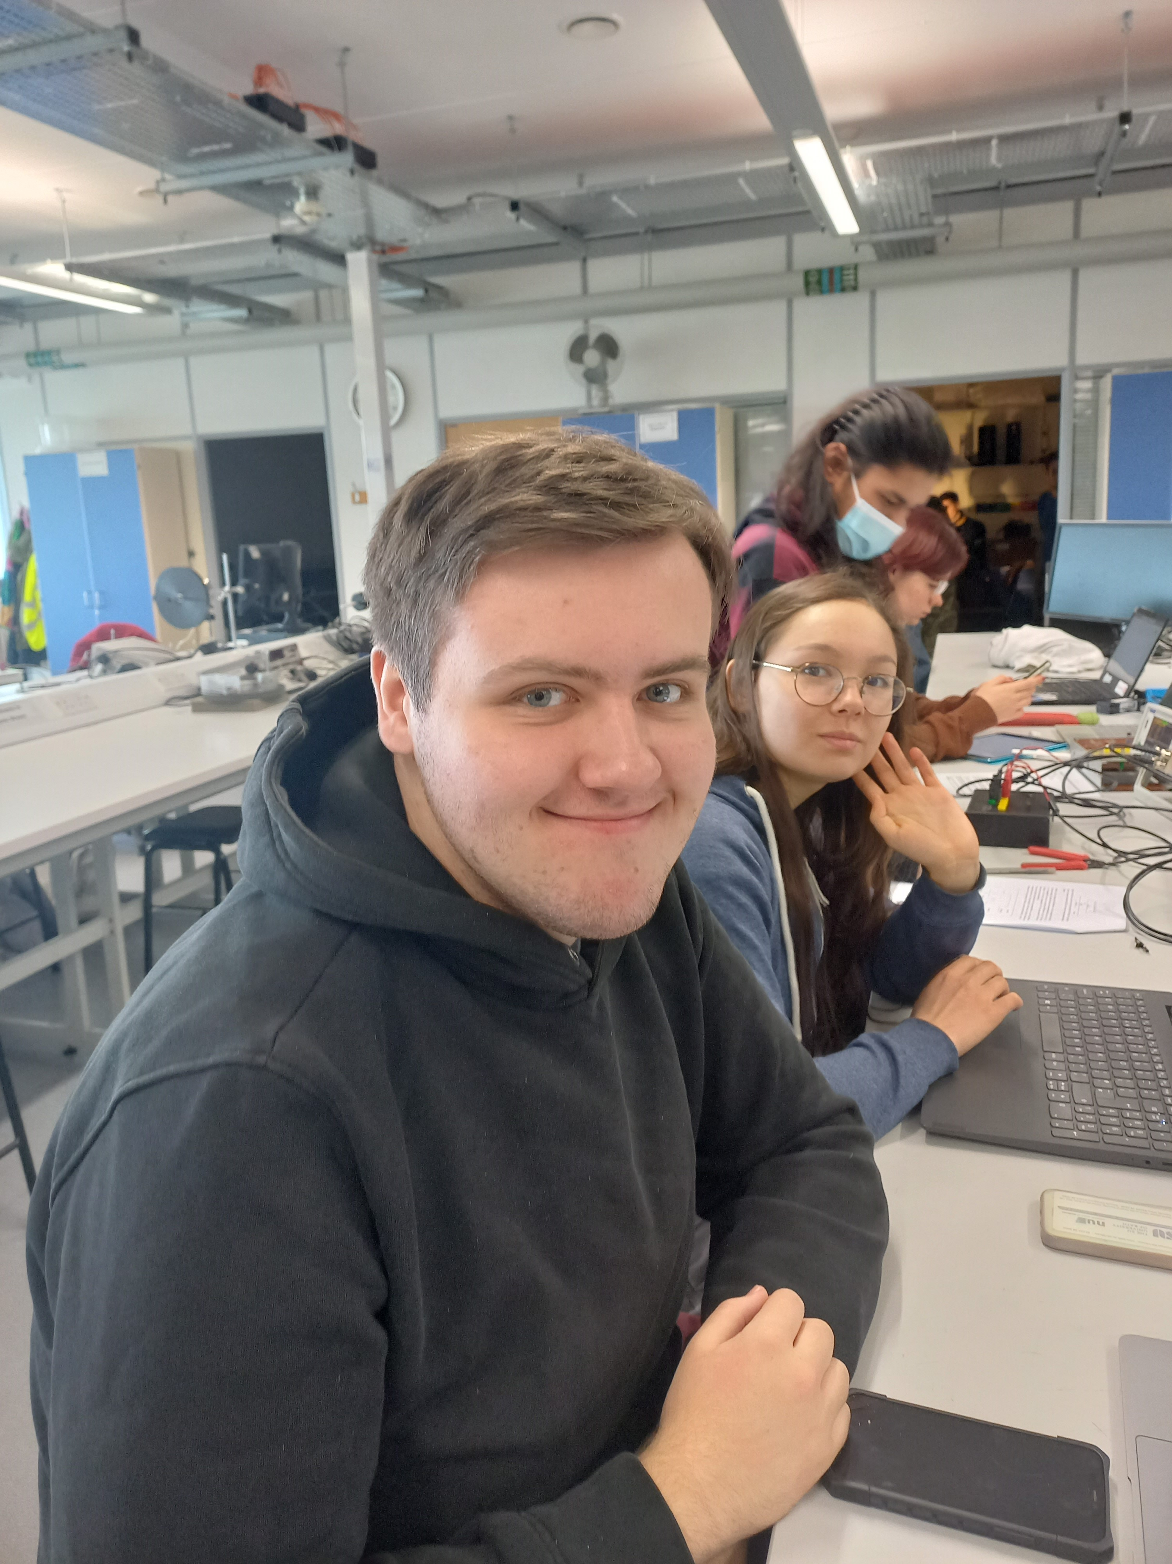 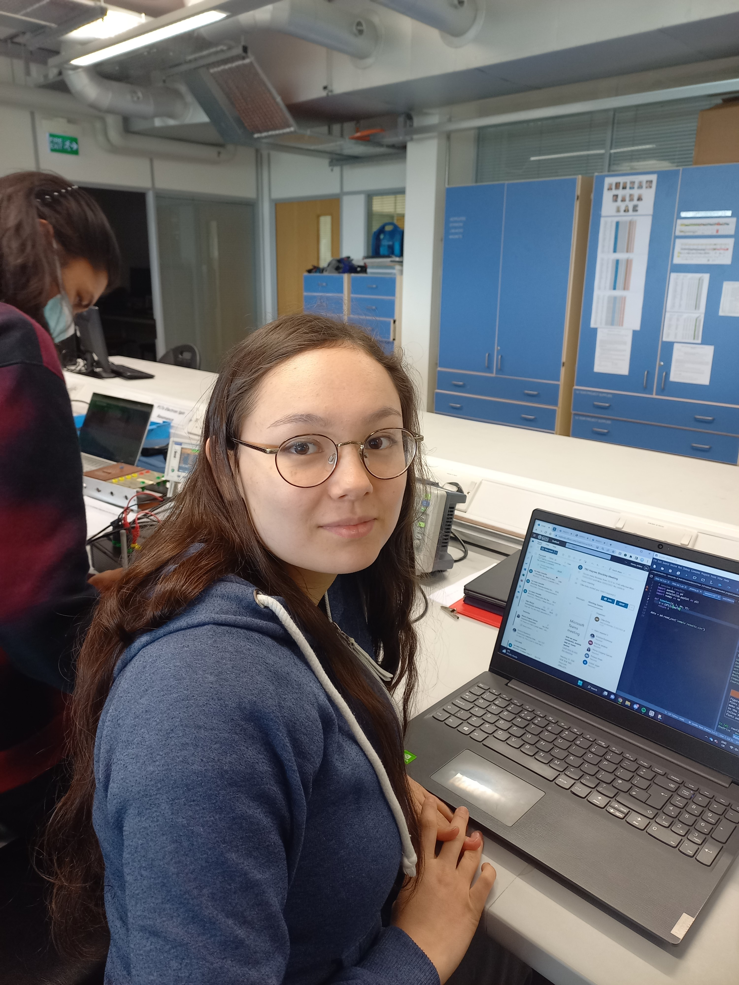

Oliver Kirby – Computational Physicist Marisa Jenkins – Experimental Analyst

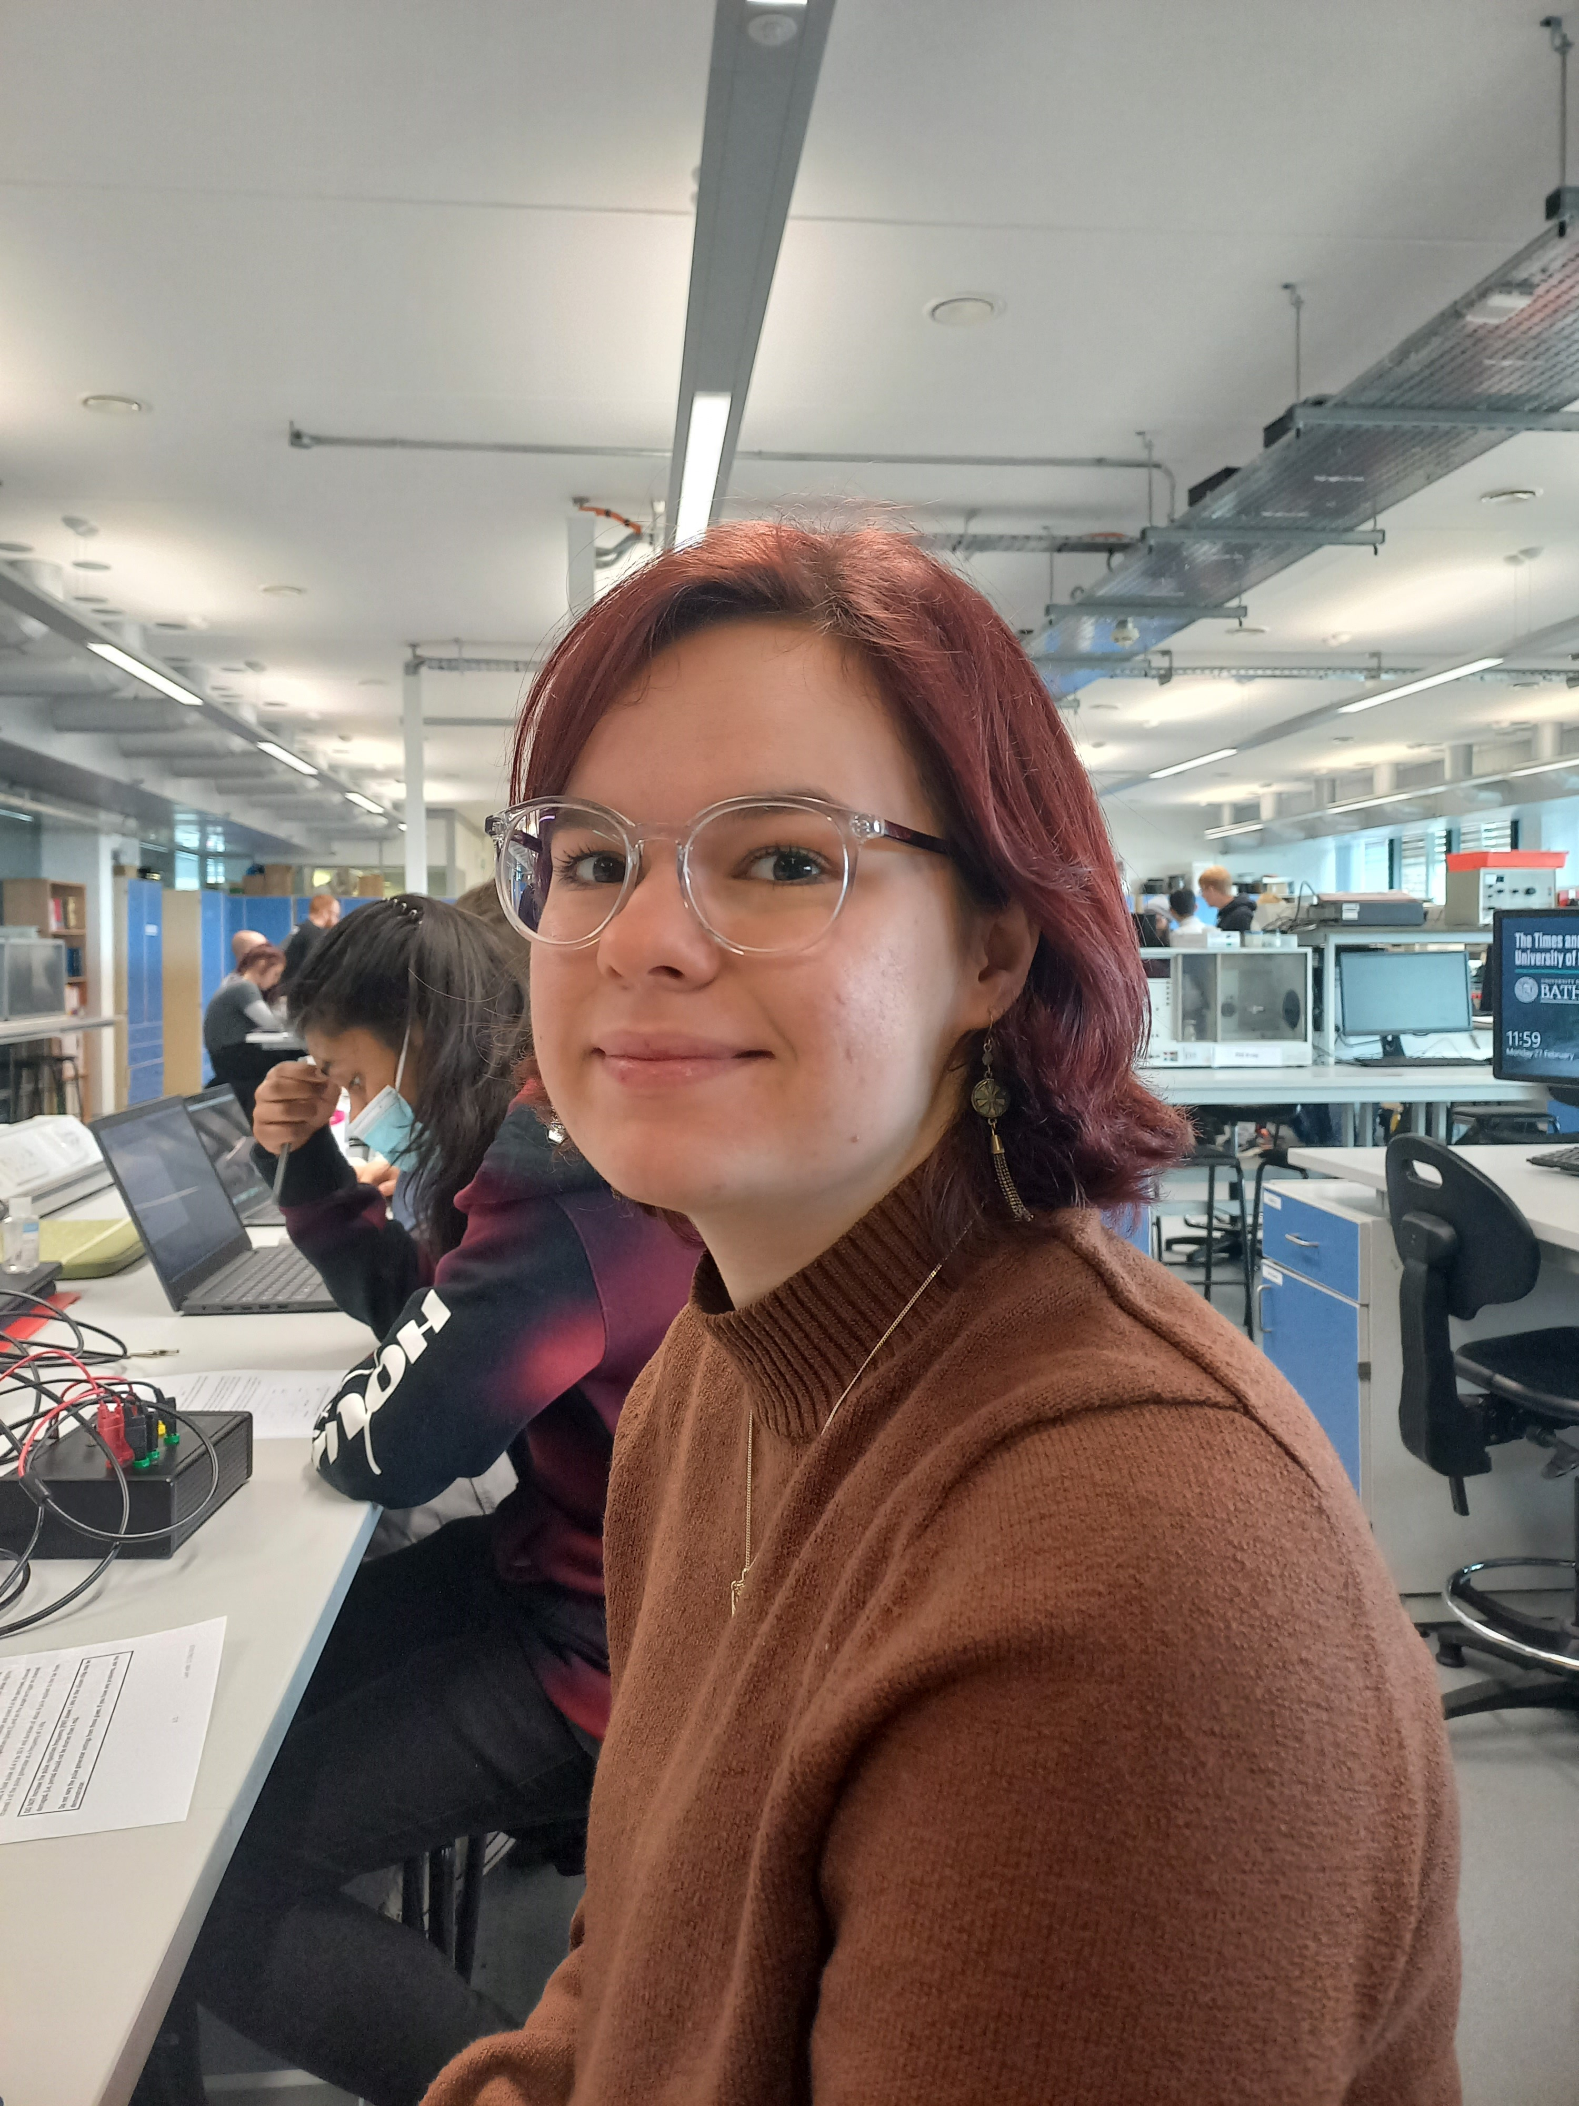 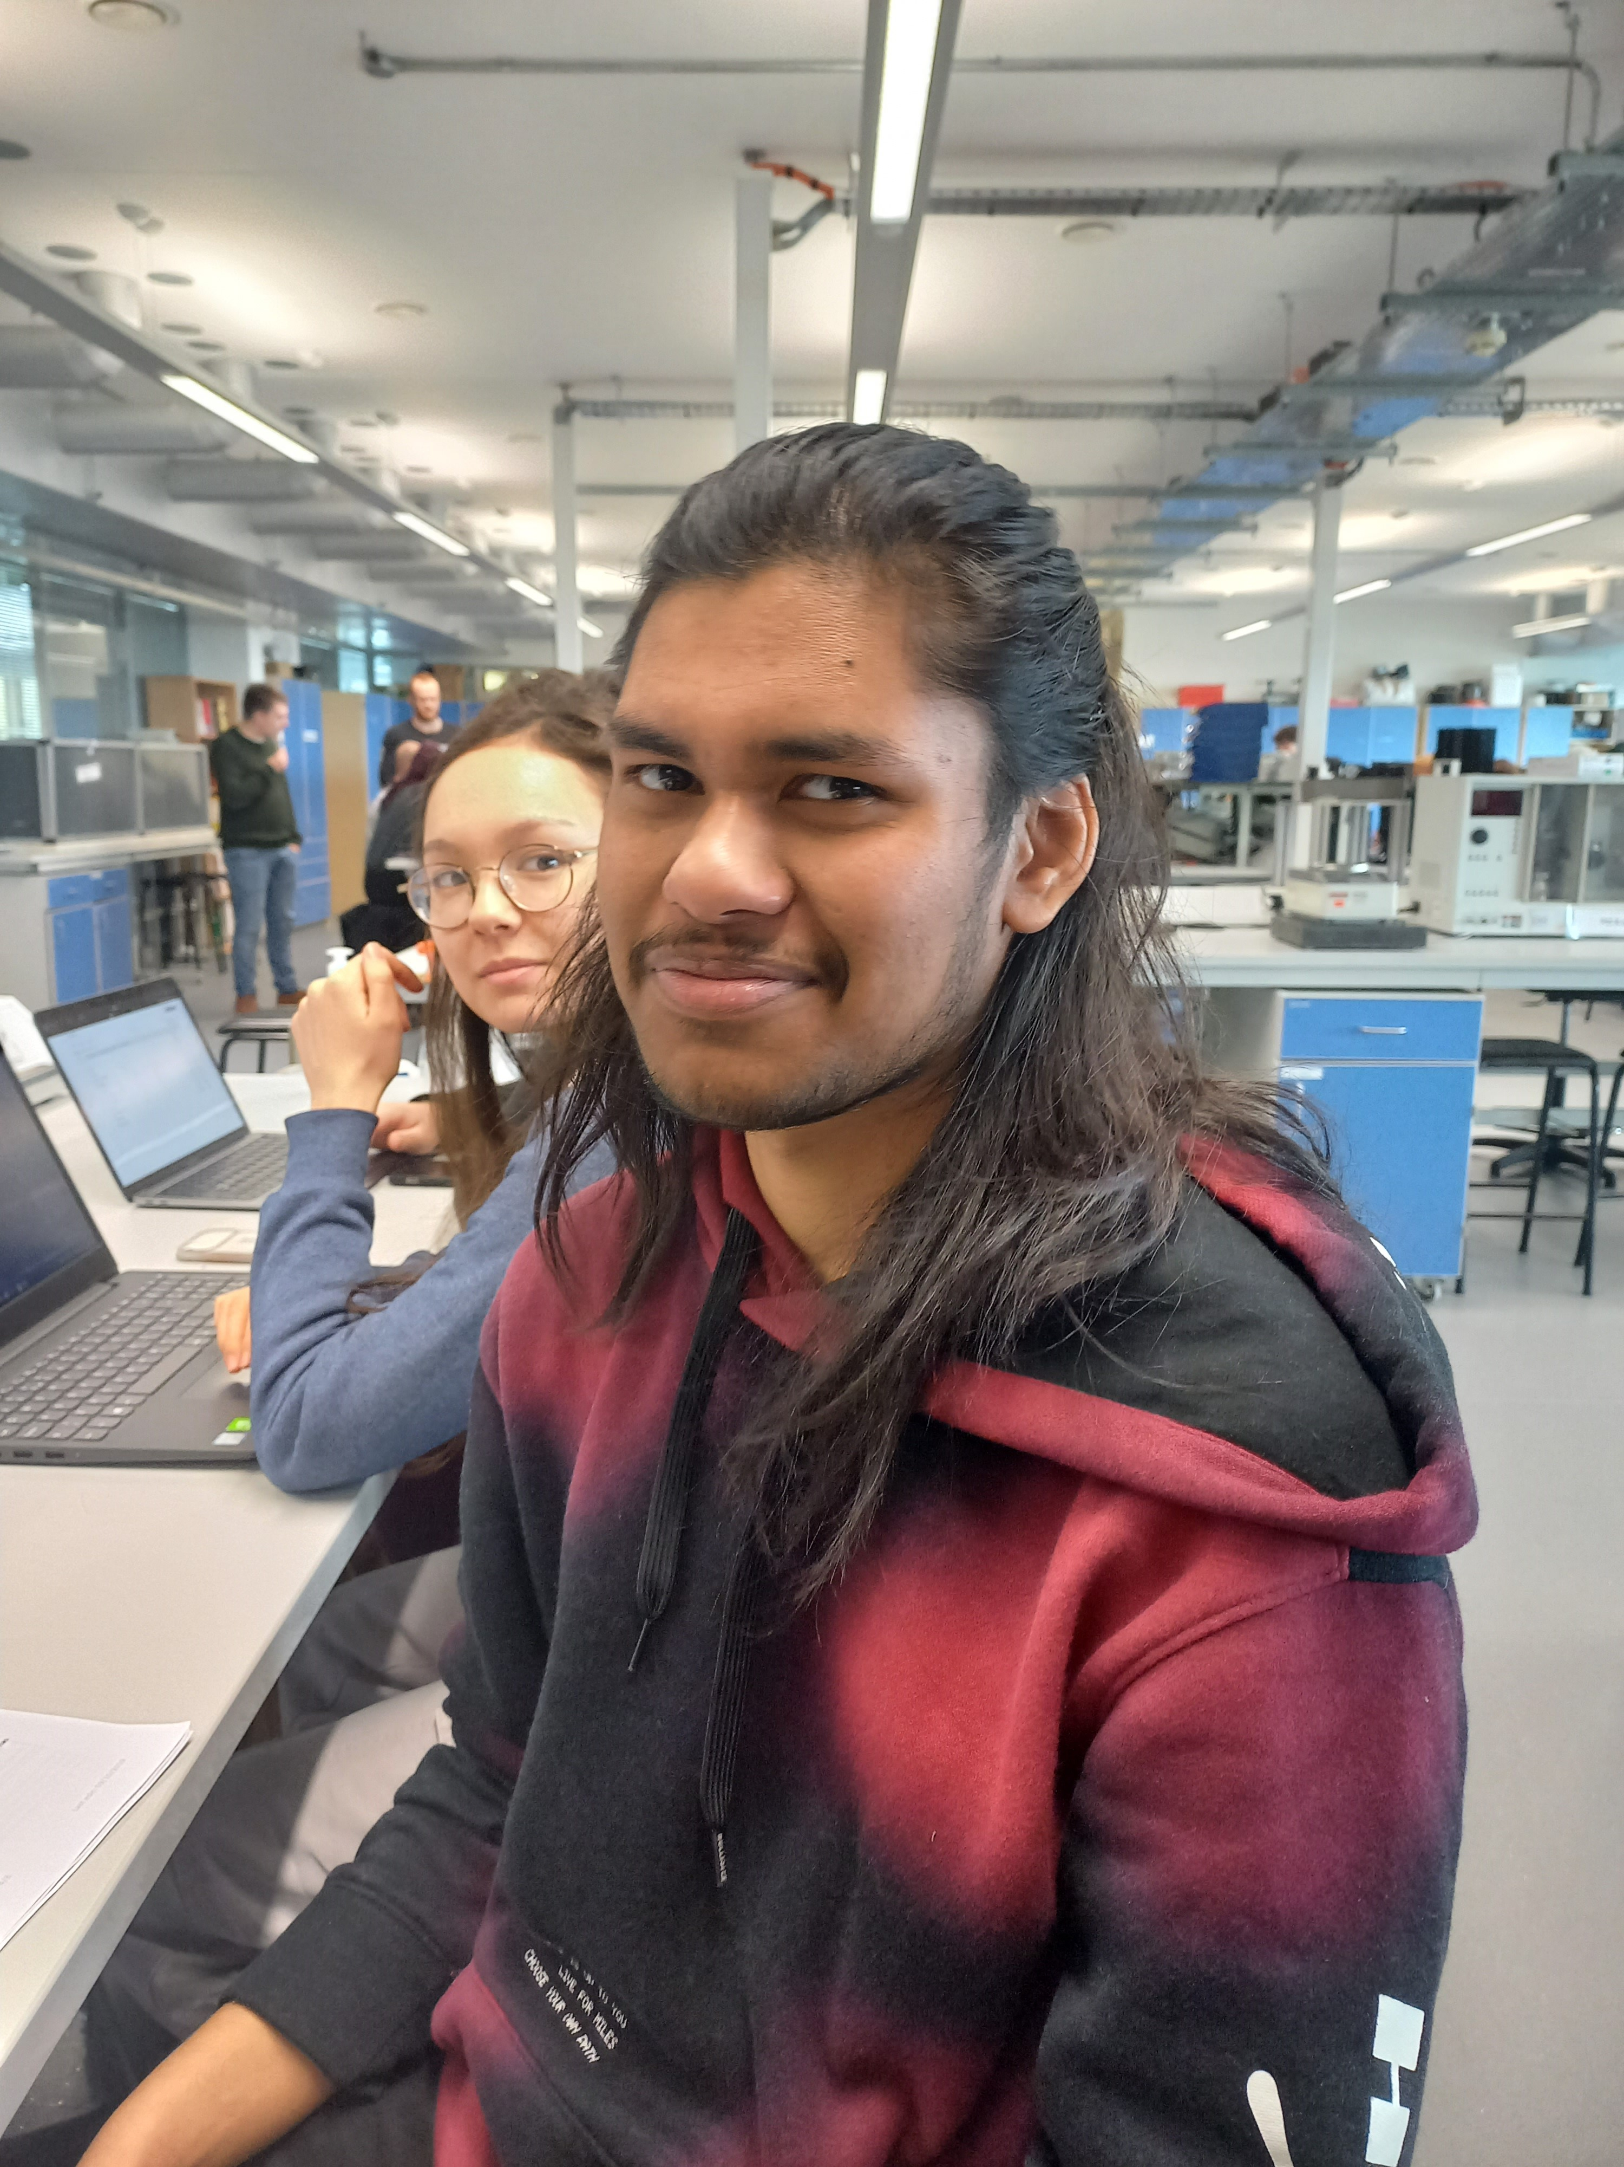

Isobel Jager – Theoretician, Ridwan Khan – Experimentalist 1

Experimentalist (secondary role)

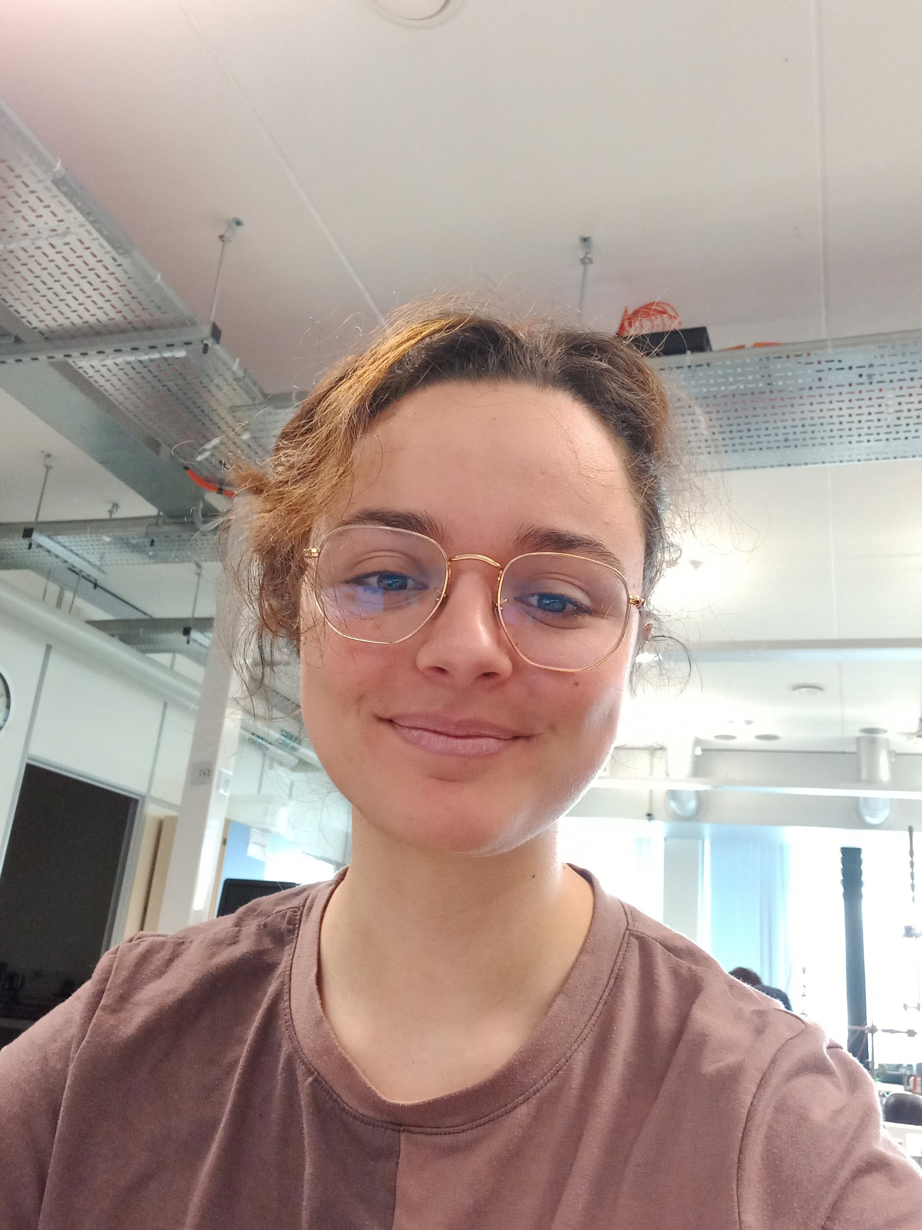

Maria Gragera Garces – Experimentalist 2, Project Manager (secondary role)